**Life Science Review**

Other Life Cycles

(water cycle is covered in Earth science)

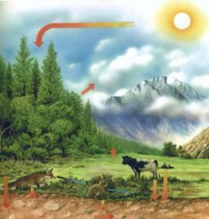

**cycle**

recurring series of events that happens in nature





**carbon dioxide - oxygen cycle**

the process by which carbon dioxide and oxygen cycle among plants, animals, and the environment

Ecosystems

|  |  |  |  |  |  |  |  |  |  |  |  |  |
| --- | --- | --- | --- | --- | --- | --- | --- | --- | --- | --- | --- | --- |
| What is the difference between a population, community and ecosystem? Organisms find these needs in their [habitat](http://www.stephsnature.com/lifescience/animalsvocab.html#habitat)   * 1. Food   2. Water   3. Space   4. A place to reproduce  |  |  |  | | --- | --- | --- | |  | Description | Example | | Population | One type of organism living in the same habitat | A herd of deer | | Community | More than one type of organism living in the same habitat | Deer, trees, insects, bacteria, mushrooms, wolves , flowers | | Ecosystem | The living and nonliving things in a habitat | Deer, trees, insects, bacteria, mushrooms, wolves , flowers, sun, lake, soil, rocks, rain, snow, heat | |
|  |
|  |
| http://o.quizlet.com/f1tyYQb17gWbrhucMFhdmw_m.jpg  **ecosystem**  all living and nonliving things that interact with each other in an environment  **Classify**  to sort into groups by characteristic or property  http://o.quizlet.com/eicjvfGPjfpOfP96w9yY6w_m.jpg |
| What are the roles of producer, consumer, and decomposer? Every organism (living thing) also has a niche (role) in its habitat. A niche is an organisms job or what the organism does in the habitat. No two organisms have the same niche.  http://o.quizlet.com/GKggz-8sbACNZGIPs4Qgng_m.jpg  **organism**  any living thing  Some niche's include  [**Predator**](http://www.stephsnature.com/lifescience/animalsvocab.html#predator): An animal that eats another animal.  [**Prey**:](http://www.stephsnature.com/lifescience/animalsunit.htm#prey%20) The animal that gets eaten  **Producer**: An orgainsm that gets its energy from the sun, such as a plant.  http://o.quizlet.com/yFCGJgUdQNXAO3xEFKwoLw_m.jpg  **producer**  an organism that makes its own food using energy from the sun through a process called photosynthesis. Examples include flowers, trees, and plants  **Consumer**: An animal that eats another animal for energy and nutrients, they are at 3 levels.  http://o.quizlet.com/V3ooqtGCVC5p4qpfDQbbaw_m.jpg  **consumer**  **Primary Consumer**: An animal that eats a producer (plant).  **Secondary Consumer**: An animal that eats a primary consumer.  **Tirtiary Consumer**: An animal that eats a secondary consumer.  **Decomposer**: An organism that gets its energy and nutrients from dead organisms and turns them into soil, such as fungi and bacteria.  http://o.quizlet.com/qLhP3b8D.Mb3uW7QNBsq0g_m.jpg  **decomposer**  an organism that breaks down dead plants and animals. This allows nutrients to go back into the soil to be reused.  <http://www.stephsnature.com/images/Websitelifescience/ecology/foodchainvocab.png> |
| How does energy move through a food web? All the food chains in a habitat are put together in a food web to show how the food chains overlap. Energy starts with the sun, then goes to plants and then consumers. |
| <http://www.stephsnature.com/images/Websitelifescience/ecology/foodweb.gif> |
| What is the relationship between a good chain and a food web? |
| The energy pyramid tell us two things about how energy moves in an ecosystem:  1. In an ecosystem the producers have the most energy and the amount of energy goes down as you move up the pyramid, the tertiary consumers have the least amount of energy in an ecosystem.  2. The producers in an ecosystem have the largest population and the size of the population goes down as you move up the pyramid, the tertiary consumers have the smallest population in an ecosystem. |
| <http://www.stephsnature.com/images/Websitelifescience/ecology/energypyramid.png> |
| What is the relationship between [Predator](http://www.stephsnature.com/lifescience/ecologyvocab.html#predator) and [Prey](http://www.stephsnature.com/lifescience/ecologyvocab.html#prey)?  |  |  | | --- | --- | | <http://www.stephsnature.com/images/Websitelifescience/ecology/pred-prey.gph1.gif> | <http://www.stephsnature.com/images/Websitelifescience/ecology/predatorprey.jpg> |   A predator is an animal that eats another animal. The animal getting eaten is the prey.  The graph above shows that as the population of the predator (fox) gets too high then the prey population (rabbit) goes down. When the prey population goes down then the predator doesn't have enough food and the prey population goes down. Because there are less predators then the prey population goes back up. This goes on and on and on.... |
| Adaptations  All organisms have adaptations that help them survive and thrive. Some adaptations are **structural**. Structural adaptations are physical features of an organism like the bill on a bird or the fur on a bear. Other adaptations are **behavioral**. Behavioral adaptations are the things organisms do to survive.  **Inherited Trait**  Factors that are obtained from the parent generation.  **Learned Characteristics**  Things about you that you did not inherit from your parents but instead learned how to do  **Influence**  Things all around you that cause you to want to do a particular thing.   |  |  | | --- | --- | | **Types of Traits** | | | **Inherit Traits** | **Learned Traits** | | Passed from parent to child (ex. eye color) | Something that comes from practice & experience | | The shape of a birds beak | Riding a bike | | spines on a cactus | Animals obeying on command |   **Physical Adaptations**   * Mimicry * Hibernation * Migration * Camouflage * Defense * Prickly spines * Body Covering – (ex. color,gills, scales…) * Claws   http://sdccsmerrill.files.wordpress.com/2013/02/untitled.png  Metamorphosis Insects go through a life cycle of changes, called metamorphosis.*Metamorphosis* is the physical change that an organism goes through as it grows and develops into an adult.Two Kinds of Metamorphosis  1. **complete metamorphosis** |
|  |

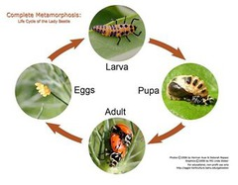

* **Complete metamorphosis is a life cycle where the physical changes are completed in 4 distinct stages:**

**Egg**

**Larva**

**Pupa**

**Adult**

**Butterflies exhibit complete metamorphosis.**

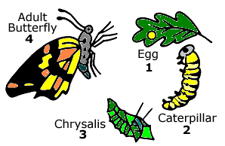

* 1. **incomplete metamorphosis**

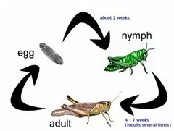

**Incomplete metamorphosis is a life cycle where the physical changes take place in *3* stages –**

1. ***Egg***
2. ***Nymph***
3. ***Adult***

**Grasshoppers and Frogs exhibit incomplete metamorphosis.**

